NUWARRA PUBLIC SCHOOL
FOOTWEAR REQUIREMENTS

The Department of Education states in the publication ‘School Uniforms in New South Wales Government Schools (2004)’, that under the Occupational Health & Safety Act 2000 schools must ensure that students are not exposed to health or safety risks while they are on Departmental premises. The school has a duty to require students to wear appropriate footwear in order to avoid injury.

ACCEPTABLE STYLES – The school expects that students wear closed in leather, lace-up style shoes. They must cover the top of the foot. It includes the following types: The full leather thick strap T-Bar Mary-Jane shoes are acceptable.

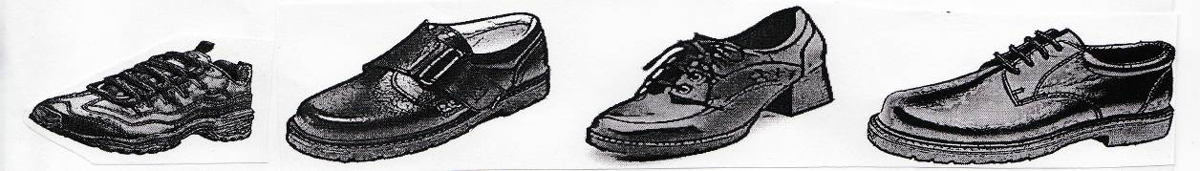

STYLES THAT ARE NOT ACCEPTABLE – Students MUST NOT wear skate shoes, black soft ‘ballet’ style shoes, open styled ‘Mary Jane’ shoes, canvas shoes or any similar. It includes those shown below:
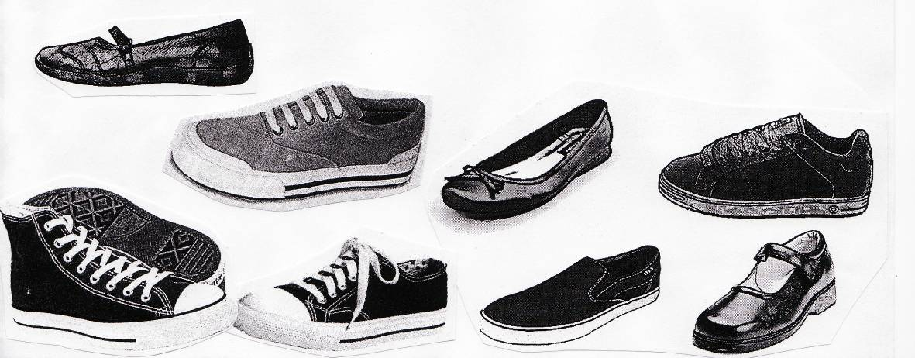

Students should only wear runners or sport shoes on the days that they are doing sport or PE.

Note: If you are not sure as what is appropriate footwear for school, consult with the school before buying a new pair

